Description: Description: G:\2017-18\SCHOOL ALL OVER\BODHI LOGO.jpg **VELAMMAL BODHI CAMPUS**

**PART TEST-II**

**Class : X** **Duration : 3.00 Hrs**

**Sub : Maths -Batch -II Marks :80**

**General Instructions:**

1. This Question Paper has 5 Sections A, B, C, D and E.

2. Section A has 20 MCQs carrying 1 mark each

3. Section B has 5 questions carrying 02 marks each.

4. Section C has 6 questions carrying 03 marks each.

5. Section D has 4 questions carrying 05 marks each.

6. Section E has 3 case based integrated units of assessment (04 marks each) with sub- parts of the values of 1, 1 and 2 marks each respectively.

7. All Questions are compulsory. However, an internal choice in 2 Qs of 5 marks, 2 Qs of 3 marks and 2 Questions of 2 marks has been provided. An internal choice has been provided in the 2marks questions of Section E

8. Draw neat figures wherever required. Take π =22/7 wherever required if not stated.

**Section-A**

|  |
| --- |
| **I. Section A has 20 MCQs carrying 1 mark each.** |
| 1. What is the area of a semicircle of diameter ‘d’?  a) d2 b) d2 c) d2 d) d2  2. A cow is tied to a peg at one corner of a rectangular field of dimensions 10m x 8m by a 3 m long rope. The area of the part of the field in which the cow can graze is:  a) 14.14 m2 b) 7.07 m2 c) 6.07 m2 d) none of these  3. The minute hand of a clock is 84 cm long. The distance covered by the tip of minute hand from 10:10 am to 10:25 am is:  a) 44cm b) 88cm c) 132 cm d) 176cm  4. Two parallel tangents are drawn to a circle at a distance of 10cm, then the radius of circle is:  a) 3cm b) 4cm c) 5cm d) 7cm  5. From a point Q, the length of the tangent to a circle is 24cm and the distance of Q from the center is 25cm. The radius of the circle is:  a) 24.51cm b) 12cm c) 15cm d) 7cm  6. A quadrilateral PQRS is drawn to circumscribe a circle. If PQ =12cm, QR=15 cm and RS=14cm, find the length of SP.  a) 15cm b) 14cm c) 12cm d) 11cm  7. The angle of elevation of a ladder leaning against a wall is 600 and the foot of the ladder is  4.6 m away from the wall. The length of the ladder is:  a) 3m b) 6m c) 8m d) 9.2m  8. When the sun’s altitude changes from 300 to 600, the length of the shadow of a tower decreases by 70m. What is the height of the tower?  a) 35m b) 140m c) 35 $\sqrt{3}$ m d) 2 $\sqrt{3}$ m  9. A cylinder and a cone have same base and same height. The ratio of their volume is:  a) 3:1 b) 1:3 c) 2:3 d) 3:2  10. What is the total surface area of a solid hemisphere of diameter ‘d’?  a) 3πd2  b) 2πd2 c) πd2 d) πd2  11. The volumes of two spheres are in the ratio 64:27. The ratio of their surface area is:  a) 4:3 b) 16:9 c) 9:16 d) 2:3  12. Construction of a cumulative frequency table is useful in determining the:  a) mean b) mode c) median d) all of these  13. Consider the following frequency distribution:   |  |  |  |  |  |  | | --- | --- | --- | --- | --- | --- | | Class | 0-5 | 6-11 | 12-17 | 18-23 | 24-29 | | Frequency | 13 | 10 | 15 | 8 | 11 |   The upper limit of the median class is:  a) 17 b) 17.5 c) 18 d) 18.5  14.If the difference of mode and median of a data is 48 then the difference of median and mean is:  a) 8 b) 12 c) 24 d) 36  15. A card is drawn from a well shuffled deck of cards. What is the probability that the card drawn neither a king nor a queen?  a) 11/13 b) 12/13 c) 11/26 d) 11/52  16. ( sec A + tan A) (1-sin A) =  a) sec A b)sin A c) cosec A d) cos A  17. If x tan 600 cos 600 = sin 600 cot 600, then x=  a) cos 300 b) tan 300 c) sin 300 d) cot 300  18. sin 2A = 2 sin A is true when A is:  a) O0 b) 300 c) 450 d) 600  19. **Assertion (A)** : The probability that a leap year has 53 Sundays is $\frac{2}{7}$.  **Reason (R)** : The probability that a non-leap year has 53 Sundays is $\frac{5}{7}$.  (a) Both assertion(A)and reason (R)are true and reason (R)is the correct explanation of assertion (A)  (b) Both assertion (A) and reason (R) are true and reason (R) is not the correct explanation of assertion (A)  (c) Assertion (A) is true but reason (R) is false.  (d) Assertion (A) is false but reason (R) is true.  20. **Assertion (A)** : The angle of elevation of the top of the tower is 300 and the horizontal distance from the observer’s eye to the foot of the tower is 50m, then the height of the tower will be $\frac{50}{3}\sqrt{3}$ m  **Reason (R)** : While using the concept of angle of elevation /depression, triangle should be a right angled triangle.  (a) Both assertion(A)and reason (R)are true and reason (R)is the correct explanation of assertion (A)  (b) Both assertion (A) and reason (R) are true and reason (R) is not the correct explanation of assertion (A)  (c) Assertion (A) is true but reason (R) is false.  (d) Assertion (A) is false but reason (R) is true. |

**Section-B**

**II. Section B has 6 questions carrying 02 marks each.**

21.Prove that the tangents drawn at the ends of a diameter of a circle are parallel.

**(OR)**

Two concentric circles are of radii 10 cm and 6 cm. Find the length of the chord of the larger circle which touches the smaller circle.

22. Given sec , find sin and cot .

23. 2 cubes each of volume 125 cm3 are joined end to end. Find the volume of the resulting cuboid.

**(OR)**

Rakhi, an engineering student, was asked to make a model shaped like a cylinder with two cones attached at its two ends by using a thin aluminium sheet. The diameter of the model is 3 cm and its length is 12 cm. If each cone has a height of 2 cm, find the volume of air contained in the model that Rakhi made.

24.A sector is cut from a circle of radius 21 cm. The angle of the sector is 1500. Find the area of its removed(sector) part.

25. One card is drawn from a well-shuffled deck of 52 cards. Find the probability that the card will

(i) be a king (ii) not be a king.

**Section-C**

**III. Section C has 6 questions carrying 03 marks each.**

26. Two different dice are thrown together. Find the probability that the numbers obtained:

(i) have a sum less than 7. (ii) have a product less than 16 (iii)is a doublet of odd numbers

27. If the mode of the following frequency distribution is 55, then find the value of x.

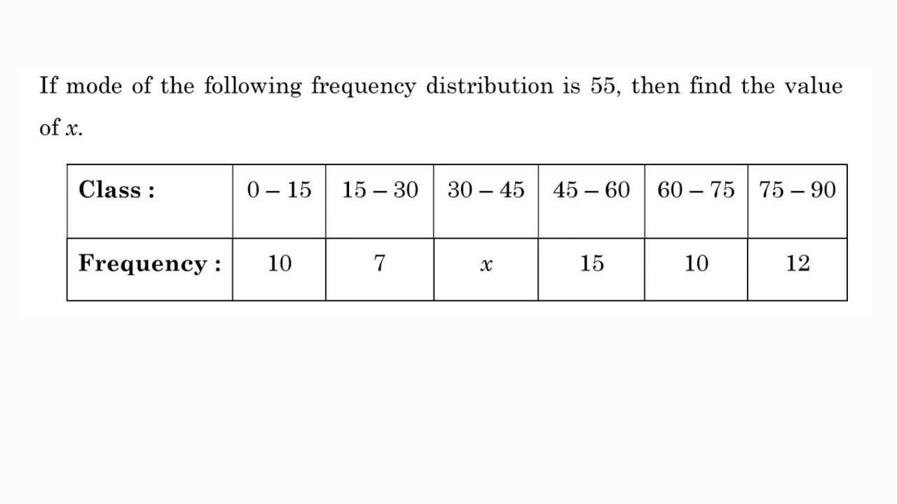

28. Area of a sector of central angle 2000 of a circle is 770 cm2.Find the corresponding arc of this sector.

**(OR)**

The perimeter of a sector of a circle of radius 5.2 cm is 16.4 cm. Find the area of the sector.

29. Two poles of equal heights are standing opposite each other on either side of the road, which is

80 m wide. From a point between them on the road, the angles of elevation of the top of the poles are 60° and 30°, respectively. Find the height of the poles and the distances of the point from the poles.

**(OR)**

The angles of depression of the top and the bottom of an 8 m tall building from the top of a

multi-storeyed building are 30° and 45°, respectively. Find the height of the multi-storeyed building and the distance between the two buildings.

30. If sin + cos = , then prove that tan + cot =2 .

31. In the figure Two tangents TP and TQ are drawn to a circle with center O from an external

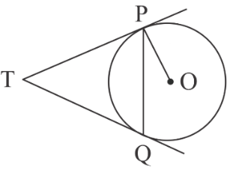 point T. Prove that ∠ PTQ = 2 ∠ OPQ .

**Section-D**

**IV. Section D has 4 questions carrying 05 marks each.**

32. (i) Prove that $\frac{1+\sec{A}}{\sec{A}}$ = $\frac{\sin^{2 }A}{1-\cos{A}}$.

(ii) Prove that (1 + cot $θ$– cosec $θ)$ ( 1 + tan $θ$ + sec $θ$) = 2 .

(OR)

(i)If a cos $θ$– b sin $θ$ = c , prove that a sin $θ$ + b cos $θ$ = $±$ $\sqrt{a^{2}+b^{2}-c^{2}}$.

(ii) Express the trigonometric ratios cos A, tan A and sec A in terms of sin A.

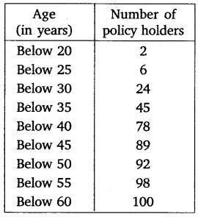33. A life insurance agent found the following data for distribution of ages of 100 policy holders. Calculate the median age, if policies are given only to persons having age 18 years onwards but less than 60 year. And also find the mode.

**(OR)**

The frequency distribution of weekly pocket money received by a group of students is given below:

Find the median of the data. And also find the mode.

|  |  |
| --- | --- |
| **Pocket money in ( Rs)** | **Number of students** |
| More than or equal to 20 | 90 |
| More than or equal to 40 | 76 |
| More than or equal to 60 | 60 |
| More than or equal to 80 | 55 |
| More than or equal to 100 | 51 |
| More than or equal to 120 | 49 |
| More than or equal to 140 | 33 |
| More than or equal to 160 | 12 |
| More than or equal to 180 | 8 |
| More than or equal to 200 | 4 |

34. (i)A spherical glass vessel has a cylindrical neck 8 cm long, 2 cm in diameter; the diameter of the spherical part is 8.5 cm. Find the volume of water it can hold.

(ii) Volume and surface area of a solid hemisphere are numerically equal. What is the diameter of hemisphere?

35. (i) Prove that opposite sides of a quadrilateral circumscribing a circle subtend supplementary angles at the center of the circle.

(ii) The lengths of tangents drawn from an external point to a circle are equal.

**Section-E**

**V.CASE BASED QUESTION.**

36. A group of students of class X visited India Gate on an education trip. The teacher and students had interest in history as well. The teacher narrated that India Gate, official name Delhi Memorial, originally called All-India War Memorial, monumental sandstone arch in New Delhi, dedicated to the troops of British India who died in wars fought between 1914 and 1919. The teacher also said that India Gate, which is located at the eastern end of the Rajpath (formerly called the Kingsway), is about 138 feet (42 metres) in height.

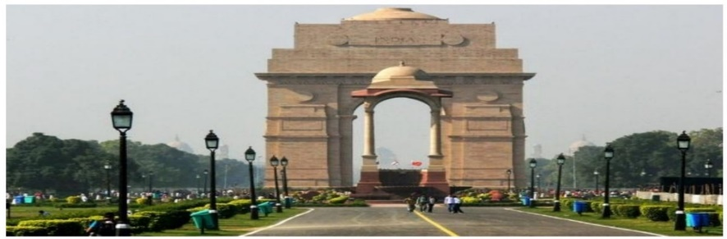

(i)Find the angle of elevation if they are standing at a distance of 42m away from the monument.

(ii)They want to see the tower at an angle of 600. So, they want to know the distance where they should stand and hence find the distance.

(iii)If the altitude of the Sun is at 600, then find the height of the vertical tower that will cast a shadow of length 20 m.

**(OR)**

The ratio of the length of a rod and its shadow is 1:1. then find angle of elevation of the Sun.

37. In an annual day function of a school, the organizers wanted to give a cash prize along with a memento to their best students. Each memento is made as shown in the figure and its base ABCD is shown from the front side. The rate of silver plating is Rs 20 per cm². ​

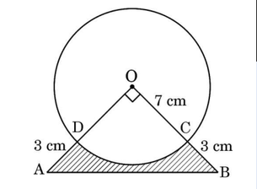

(i) What is the area of the quadrant ODCO?

(ii) Find the area of ΔAOB.

(iii) what is the total cost of silver plating the shaded part ABCD. What is the length of the arc CD.

**(OR)**

area of the major segment.

# 38. In a coffee shop, coffee is served in two types of cups. One is cylindrical in shape with diameter

# 7 cm and height 14 cm and the other is hemispherical with diameter 21 cm.

# Srishti - A Corporate Gifting Company

# File:Coffee cup icon.svg - Wikipedia

# Based on the above, answer the following questions:

# (i) Find the area of the base of the cylindrical cup.

# (ii) What is the curved surface area of the cylindrical cup?

# (iii) What is the capacity of the hemispherical cup?

# (OR) Find the capacity of the cylindrical cup.